**EDUNET FOUNDATION-Class Exercise Notebook**

**LAB 3 – Collecting Sensors Data from Cloud**

Step 1**.** Refer back to Cumulocity IOT Device Management dashboard

Step 2. Open dashboard of connected devices.

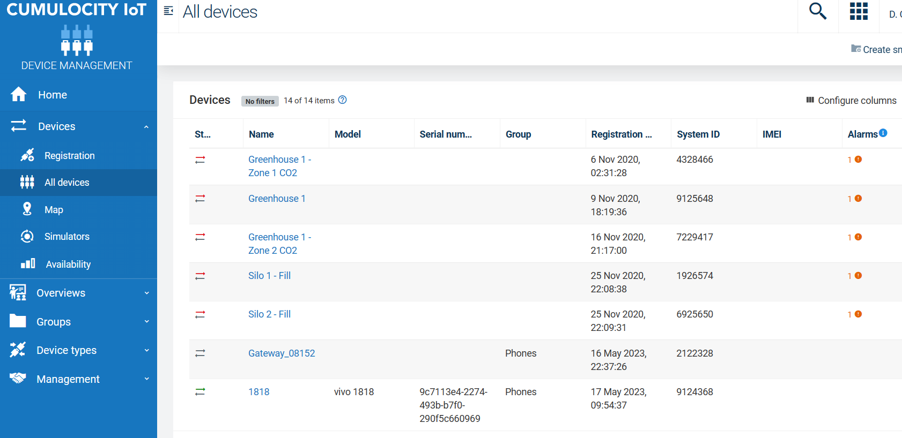

Step 3. Open your connected device of interest.

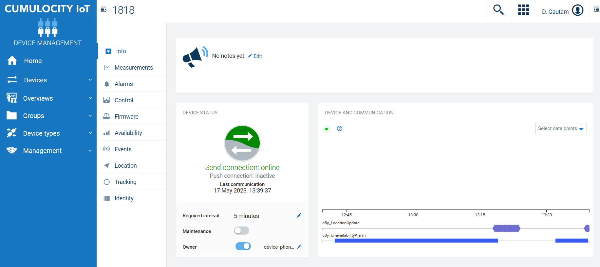

Step 4. Refer to Measurement section to view the device activity. Click on More to download device sensor data

